NFS Server SSH Access and Package Setup
Topic: Connect to the NFS server EC2 instance and prepare the NFS share directory
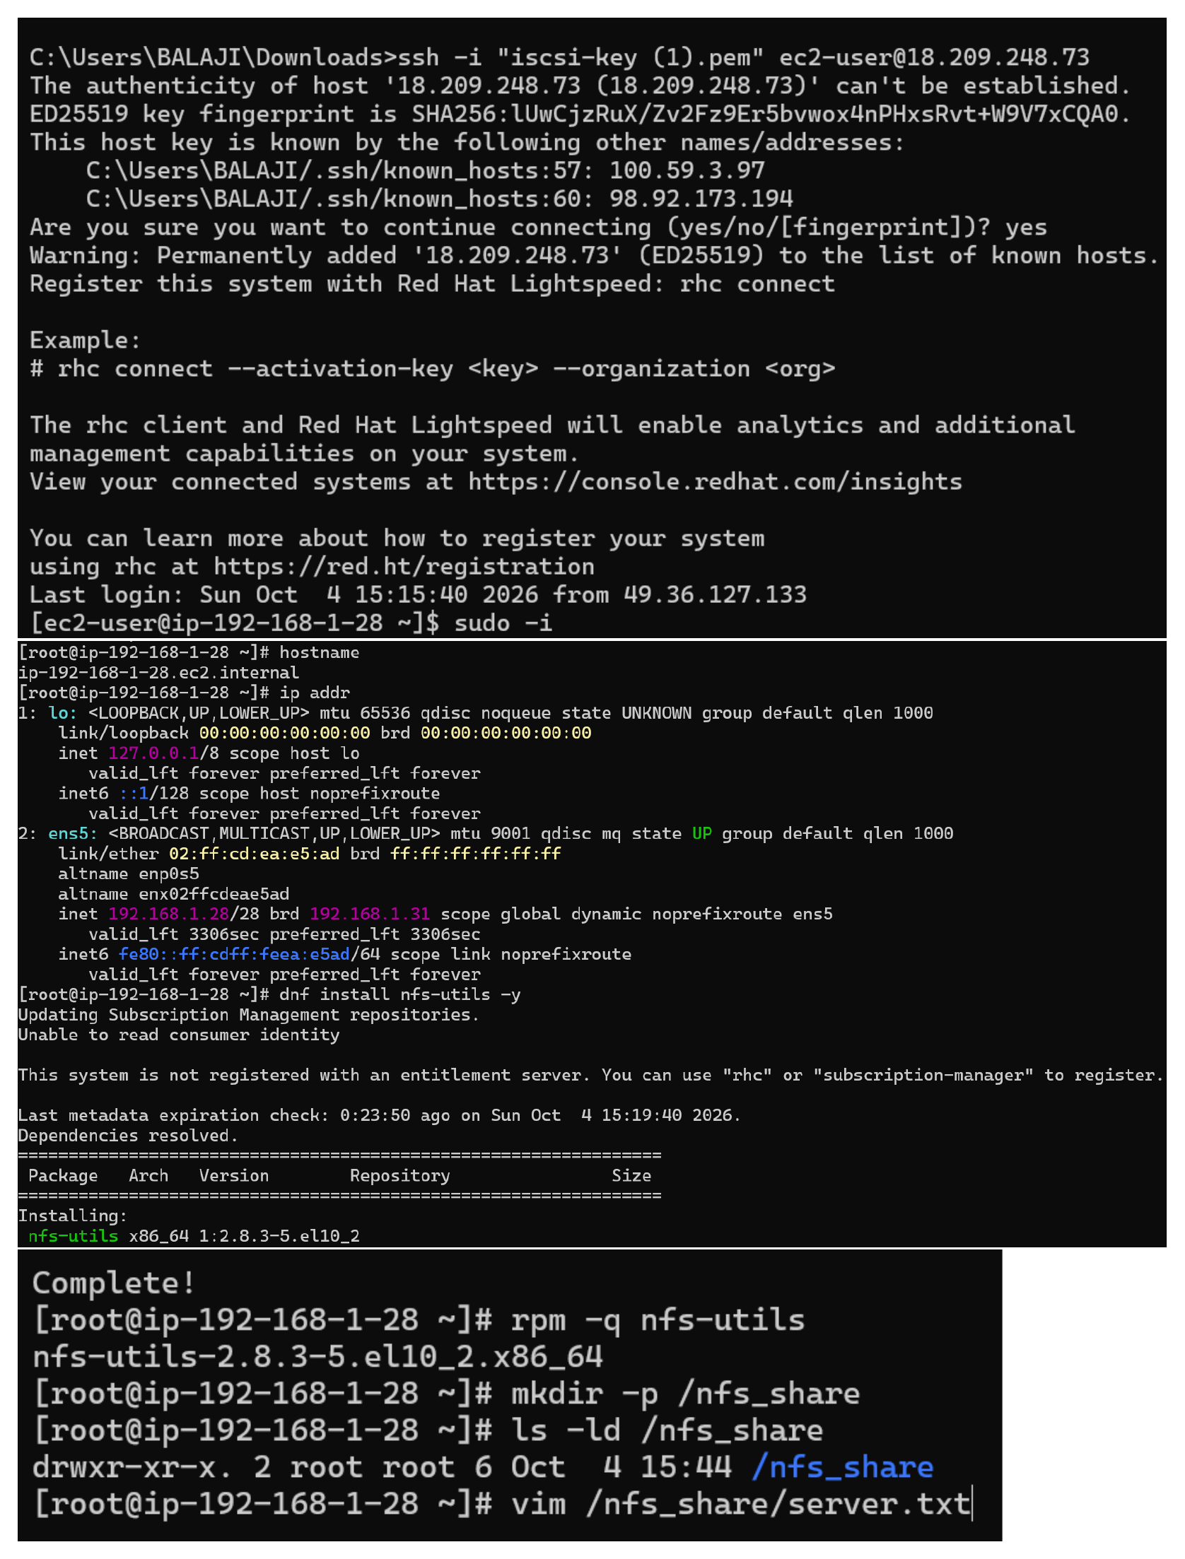
Action: SSH is used with the iscsi-key PEM file to reach the RHEL EC2 server. The hostname and IP address are checked, nfs-utils is installed with dnf, /nfs_share is created, and server.txt is opened for editing.

Create the NFS Server File
Topic: Create server.txt inside the NFS shared directory
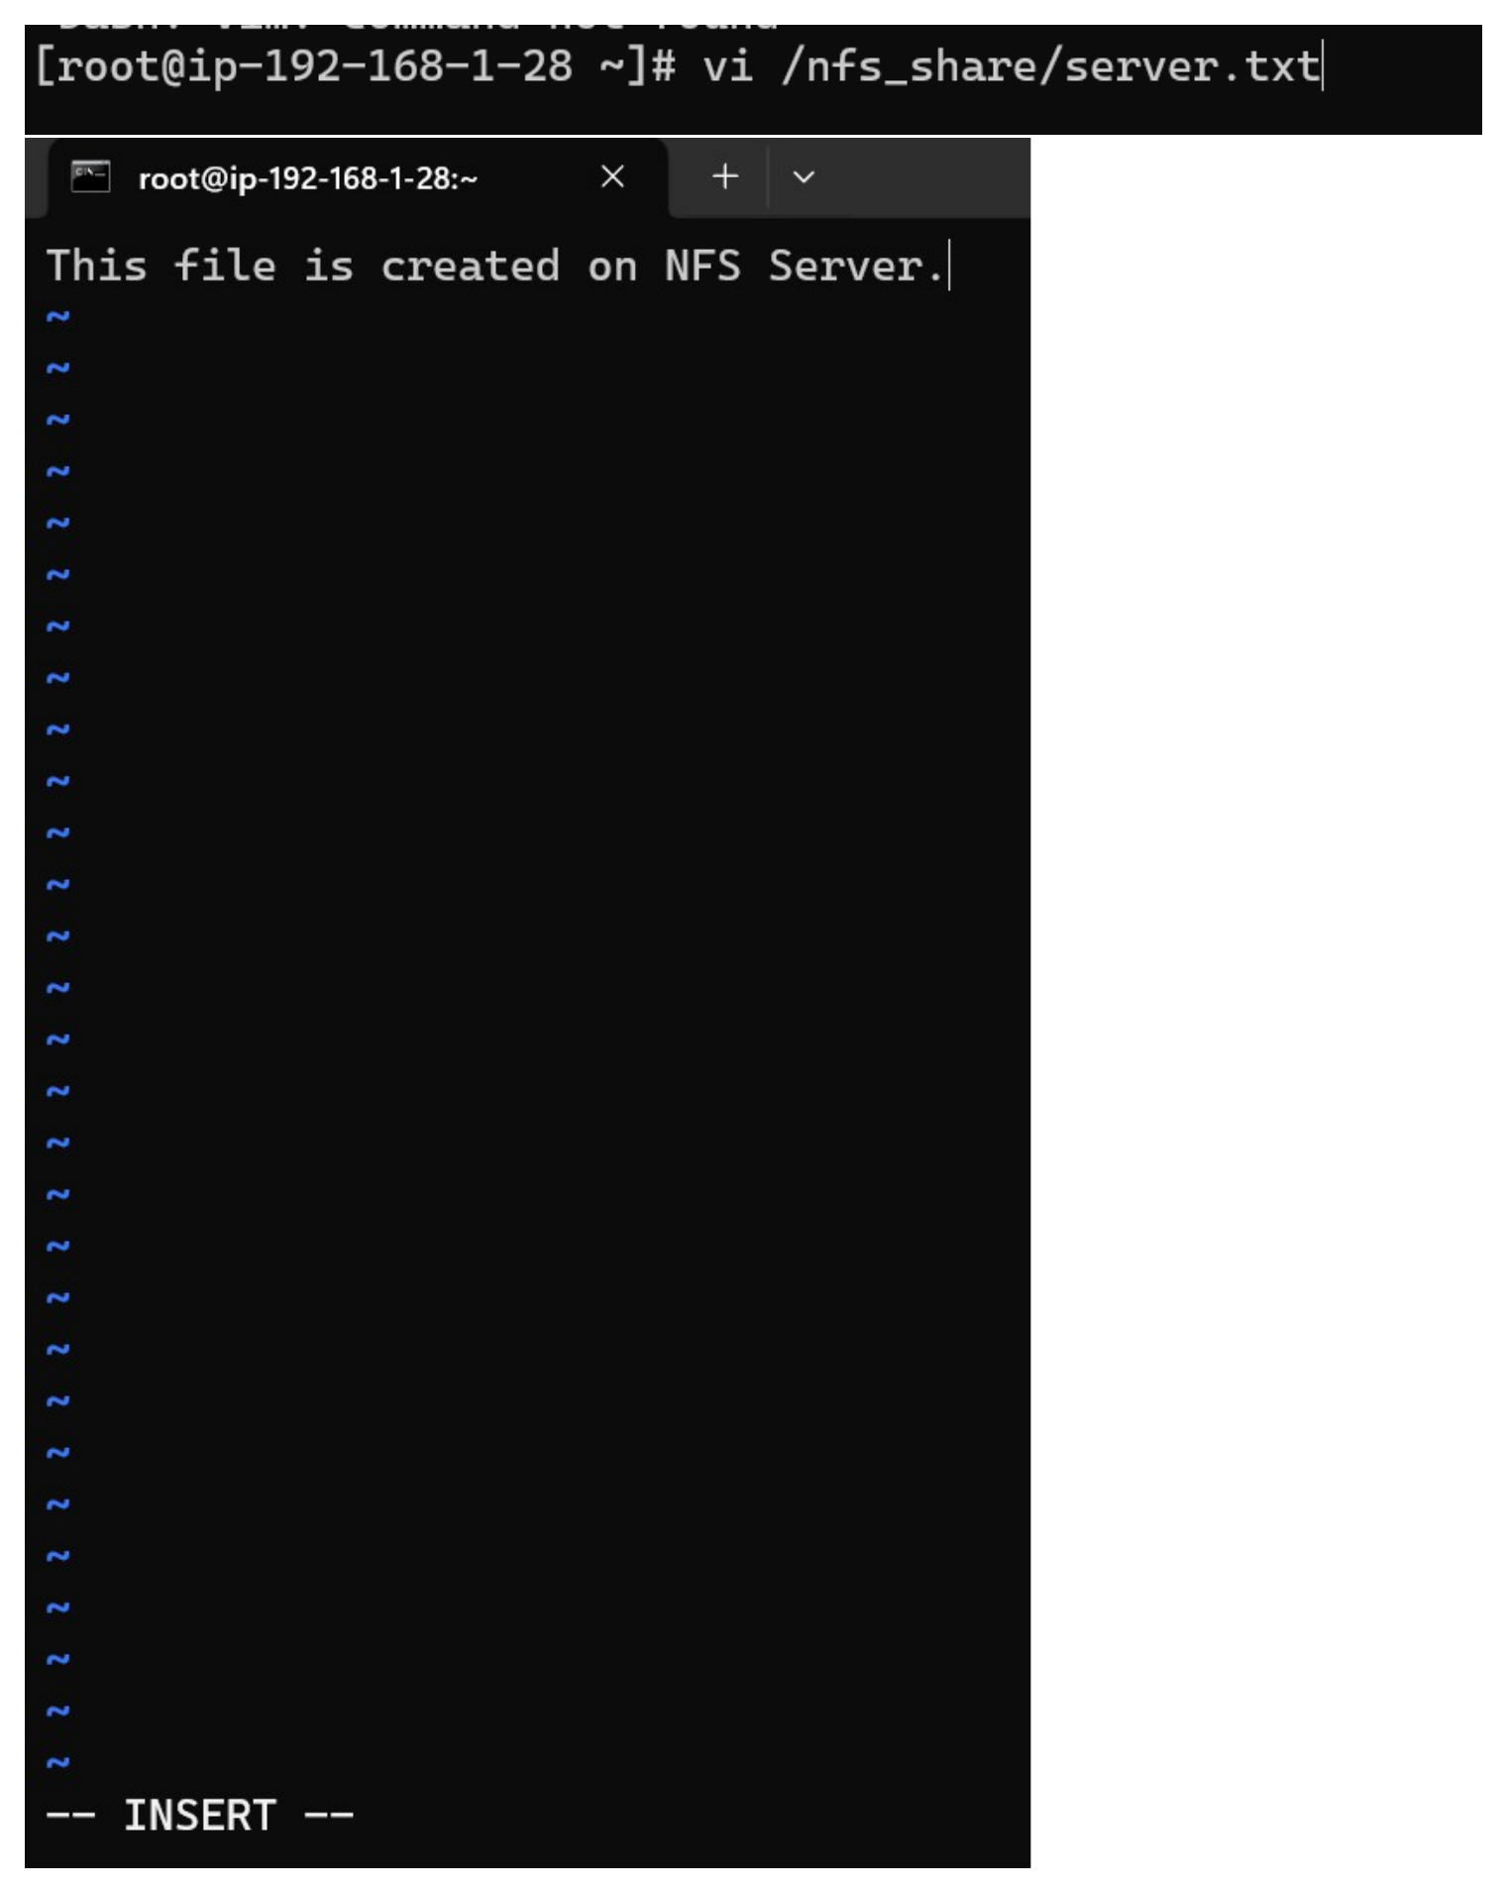
Action: The vi editor is used on /nfs_share/server.txt and the file content is entered as “This file is created on NFS Server.”.

Verify NFS File and VPC Network Resources
Topic: Confirm the NFS server file and review VPC, subnet, route table and Internet Gateway resources
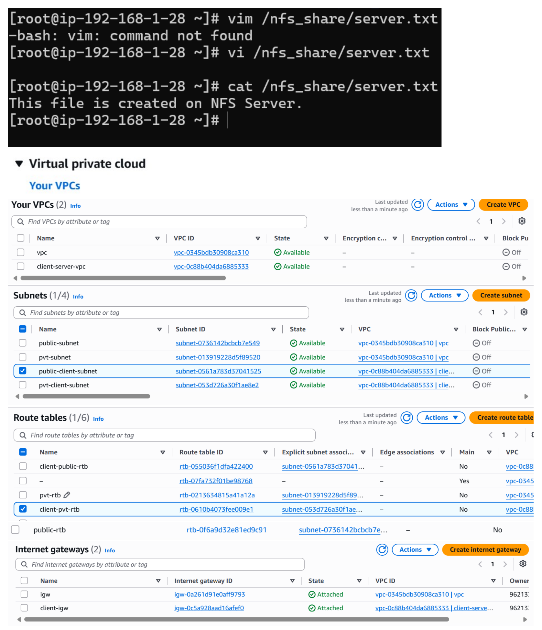
Action: cat /nfs_share/server.txt confirms the server file content. The AWS VPC console also shows the vpc and client-server-vpc, their subnets, route tables and attached Internet Gateways.

Launch the Client EC2 Instance
Topic: Configure the client EC2 instance using RHEL 10 and a t3.micro instance
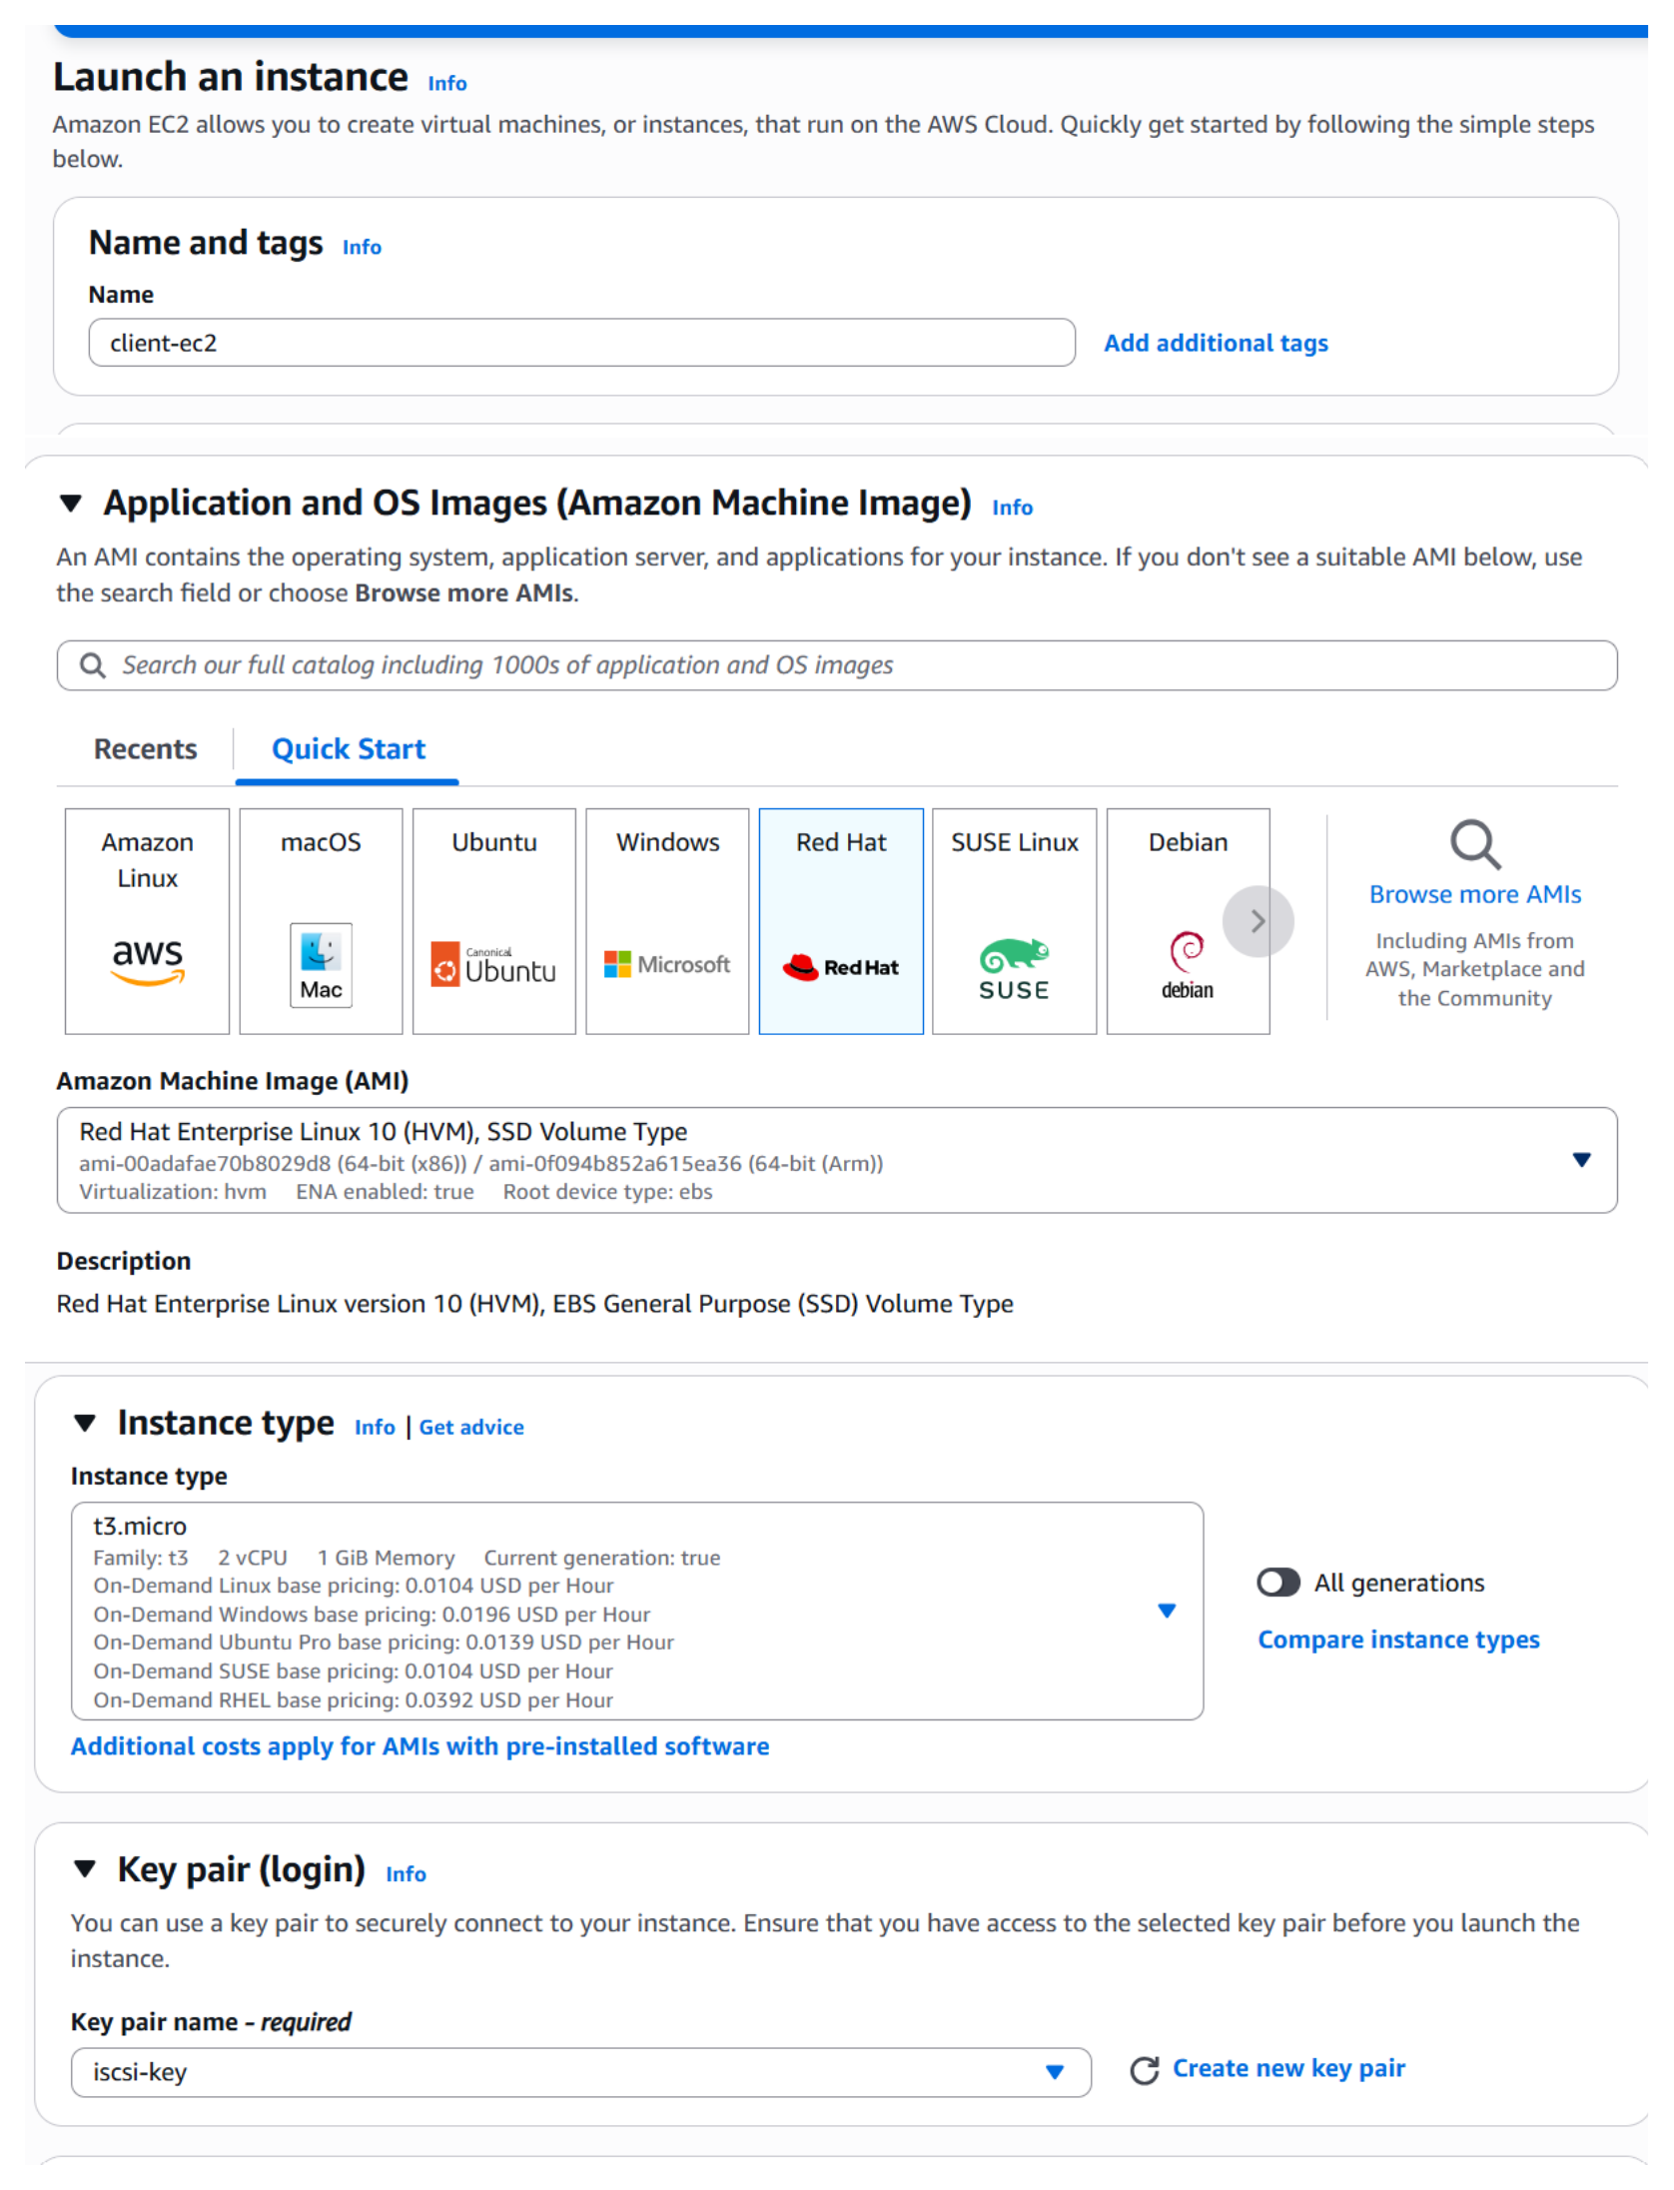
Action: The EC2 launch form is filled for client-ec2 with Red Hat Enterprise Linux 10, instance type t3.micro, and the iscsi-key key pair.

Configure Client Network and Security Group
Topic: Select the client VPC/subnet and allow SSH access
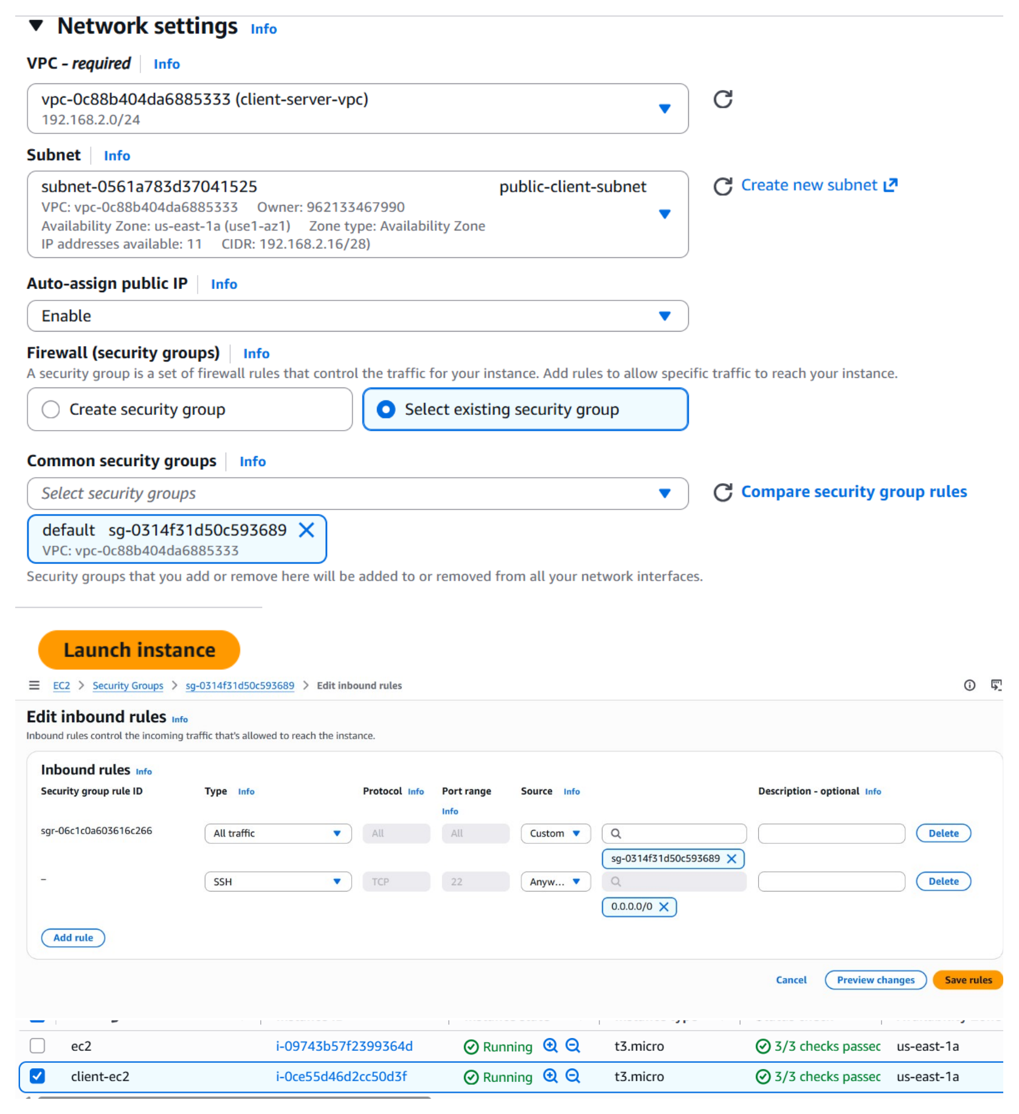
Action: The client-server-vpc and public-client-subnet are selected with auto-assign public IP enabled. The existing security group is selected and an SSH TCP port 22 inbound rule is configured before launching client-ec2.

Connect to the NFS Client and Check Its IP
Topic: SSH into client-ec2 and verify its private network address
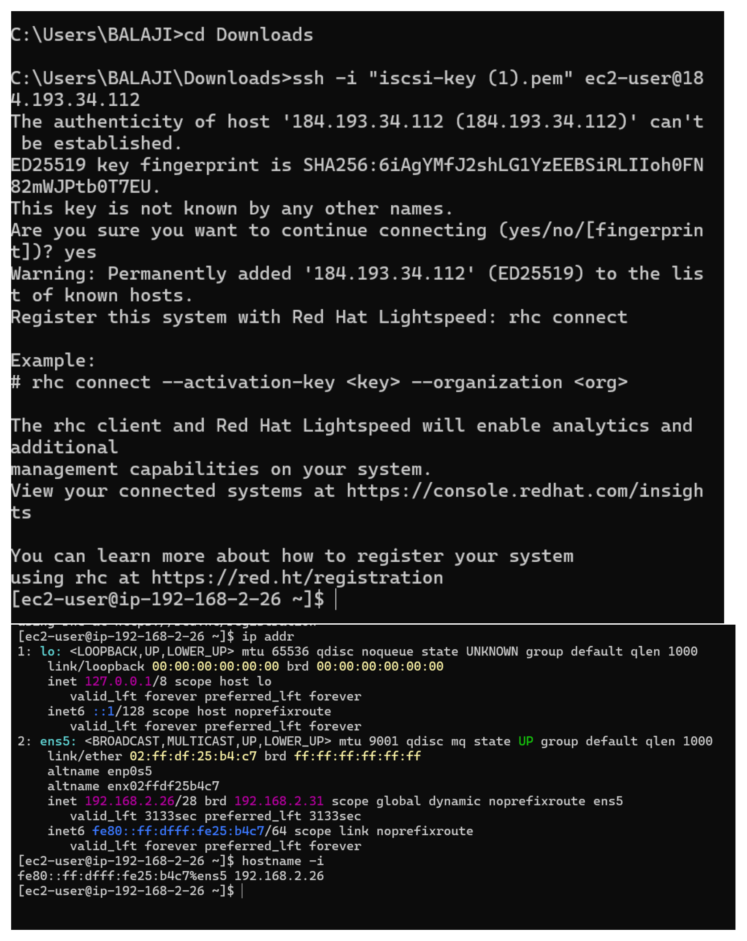
Action: SSH connects to the client EC2 instance. ip addr and hostname -I confirm the client is on the 192.168.2.0/24 network with address 192.168.2.26.

Configure /etc/exports for the NFS Share
Topic: Export /nfs_share to the client subnet/host
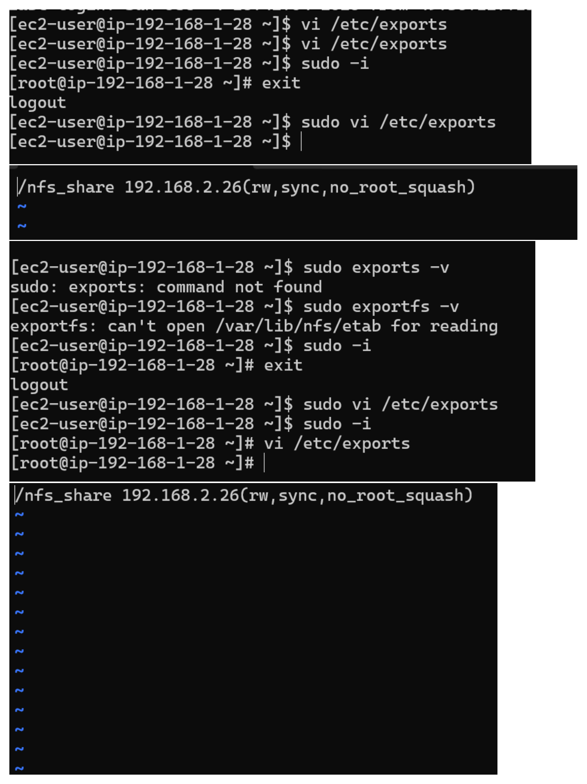
Action: The NFS server’s /etc/exports file is edited as /nfs_share 192.168.2.26(rw,sync,no_root_squash). The screenshot also shows the correction from the unavailable exports command to exportfs.

Start NFS Server and Open Required Firewall Ports
Topic: Enable NFS services and permit NFS/RPC traffic
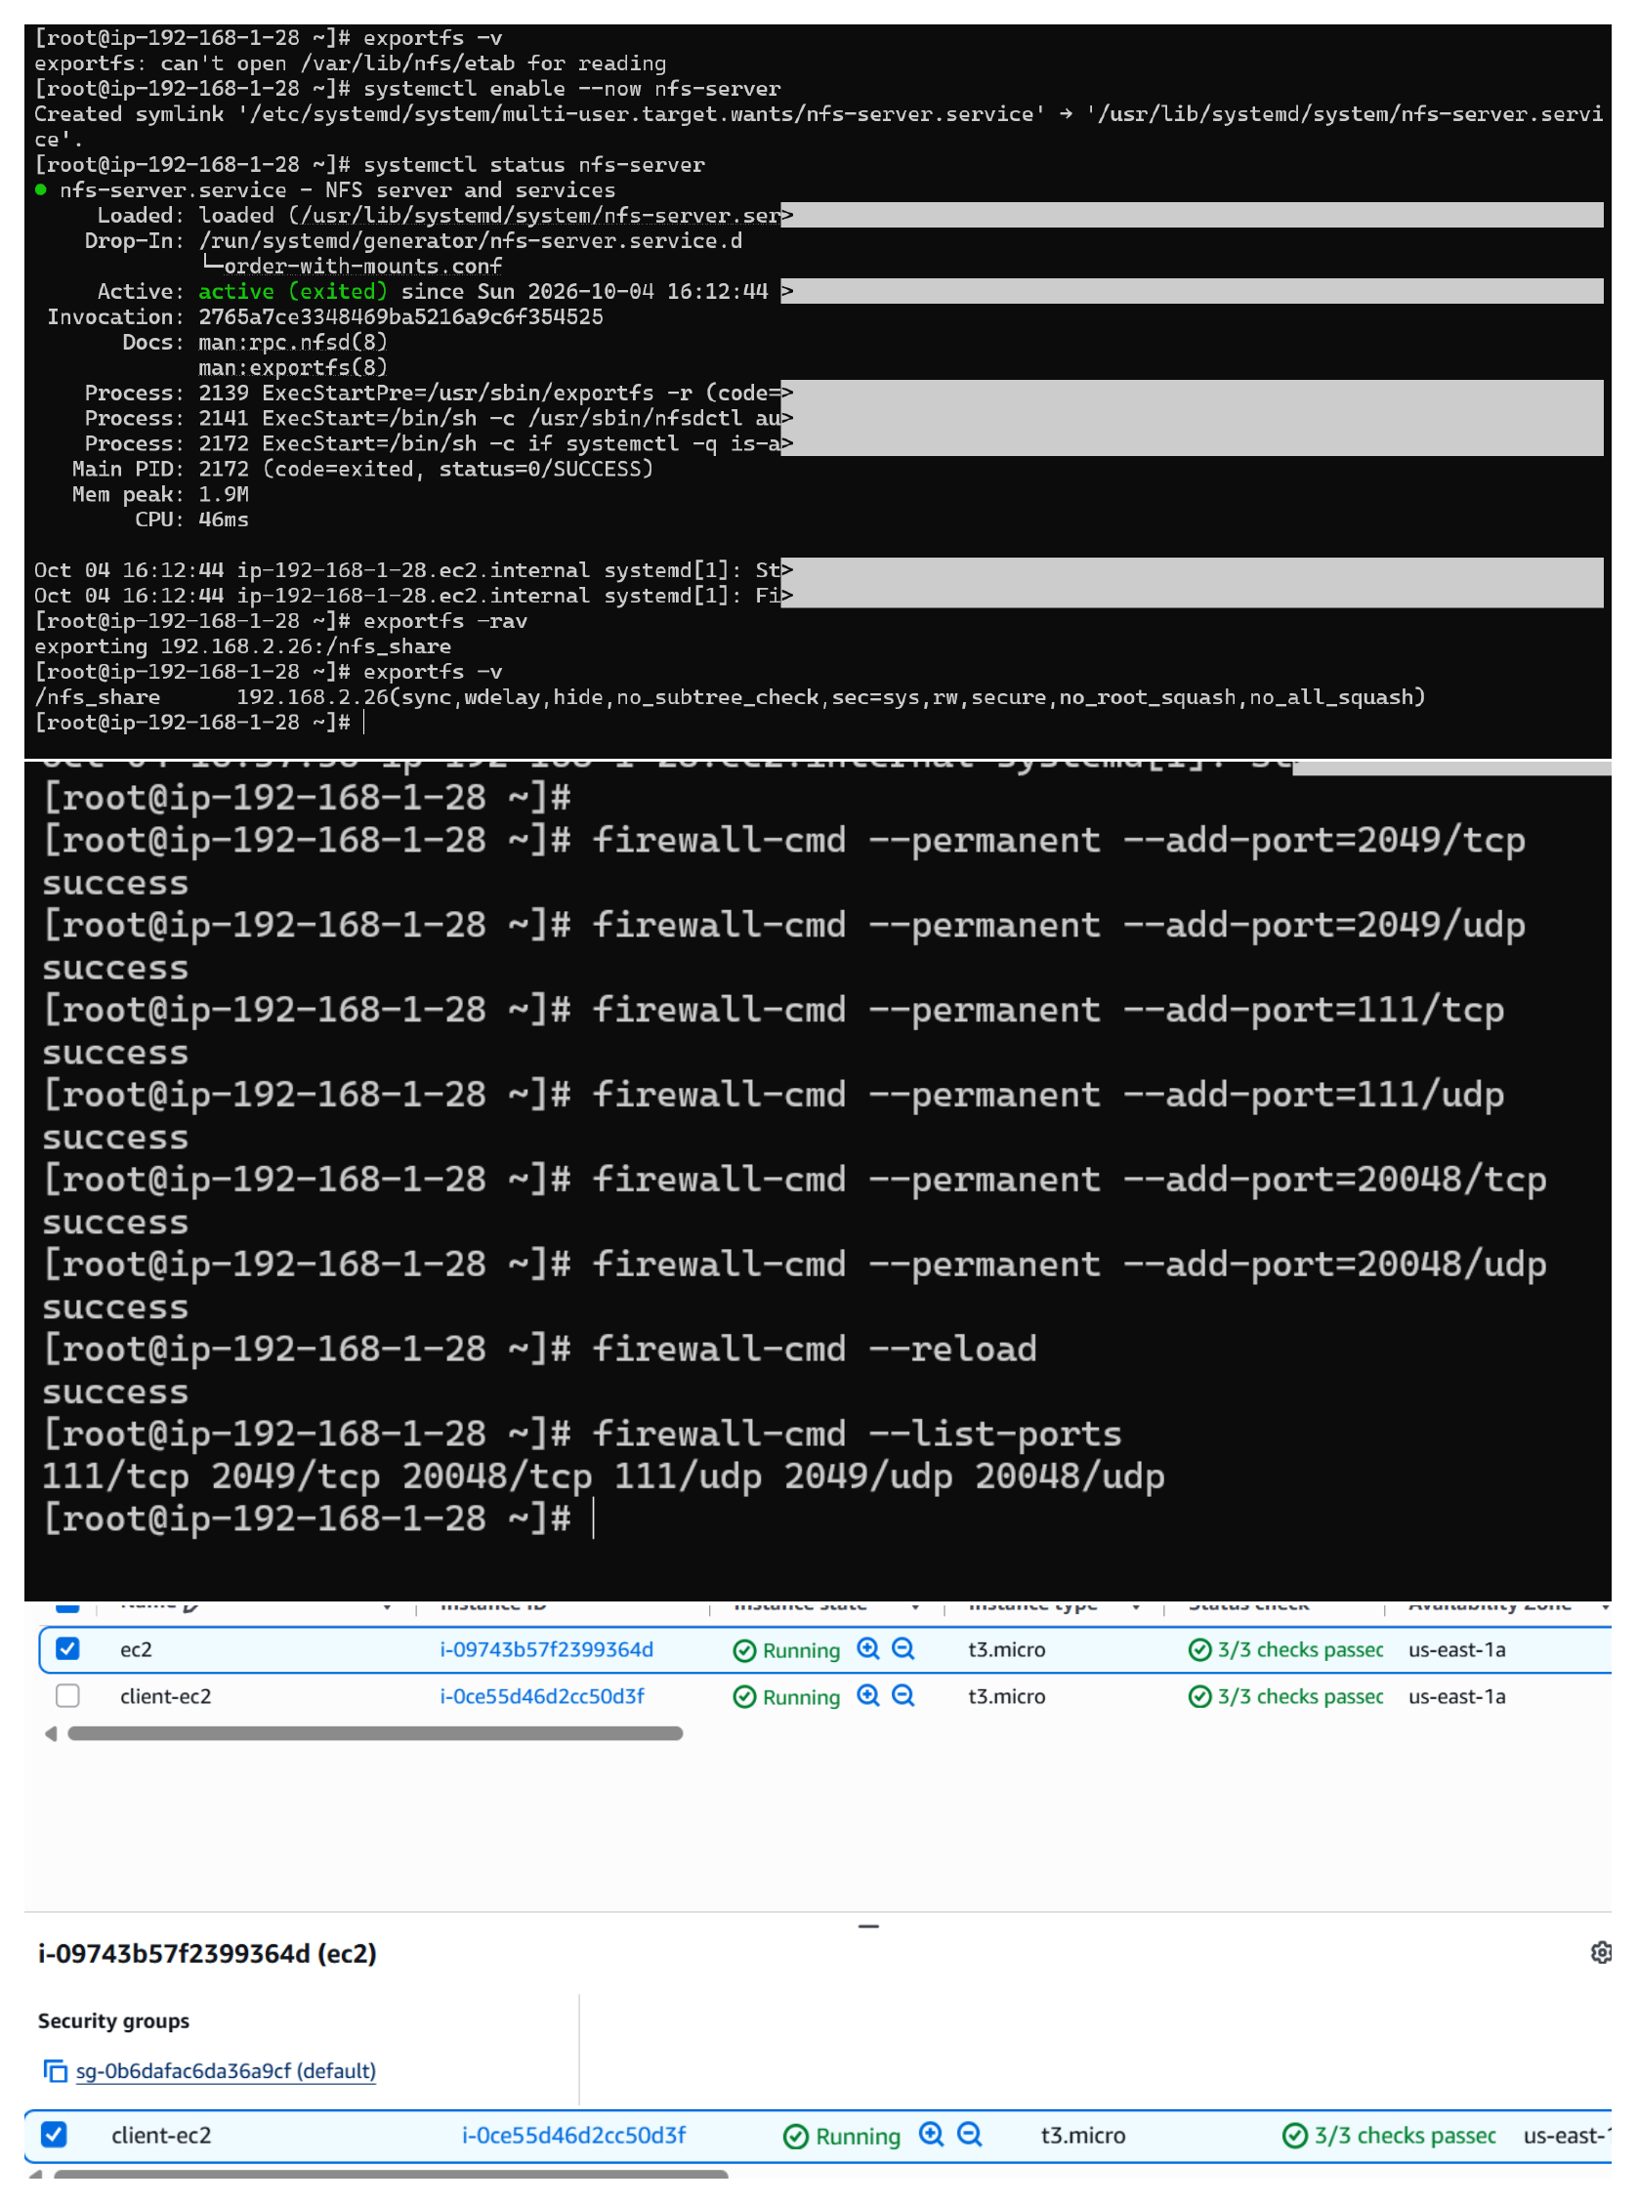
Action: nfs-server is enabled and verified active. exportfs -rav exports /nfs_share to 192.168.2.26, and firewall-cmd permanently allows TCP/UDP ports 2049, 111 and 20048 before reloading and listing the ports.

Add NFS Ports to the EC2 Security Group
Topic: Configure inbound TCP/UDP rules for NFS and RPC
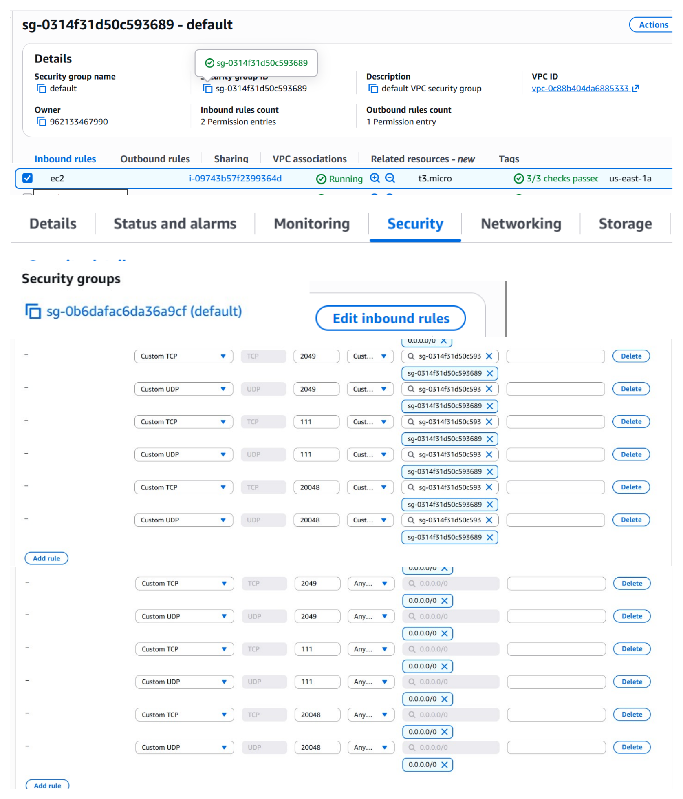
Action: The EC2 security group inbound rules are edited to allow TCP and UDP traffic on ports 2049, 111 and 20048, using the shown security-group/source configuration.

Install NFS Utilities on the Client
Topic: Prepare the client EC2 instance for NFS mounting
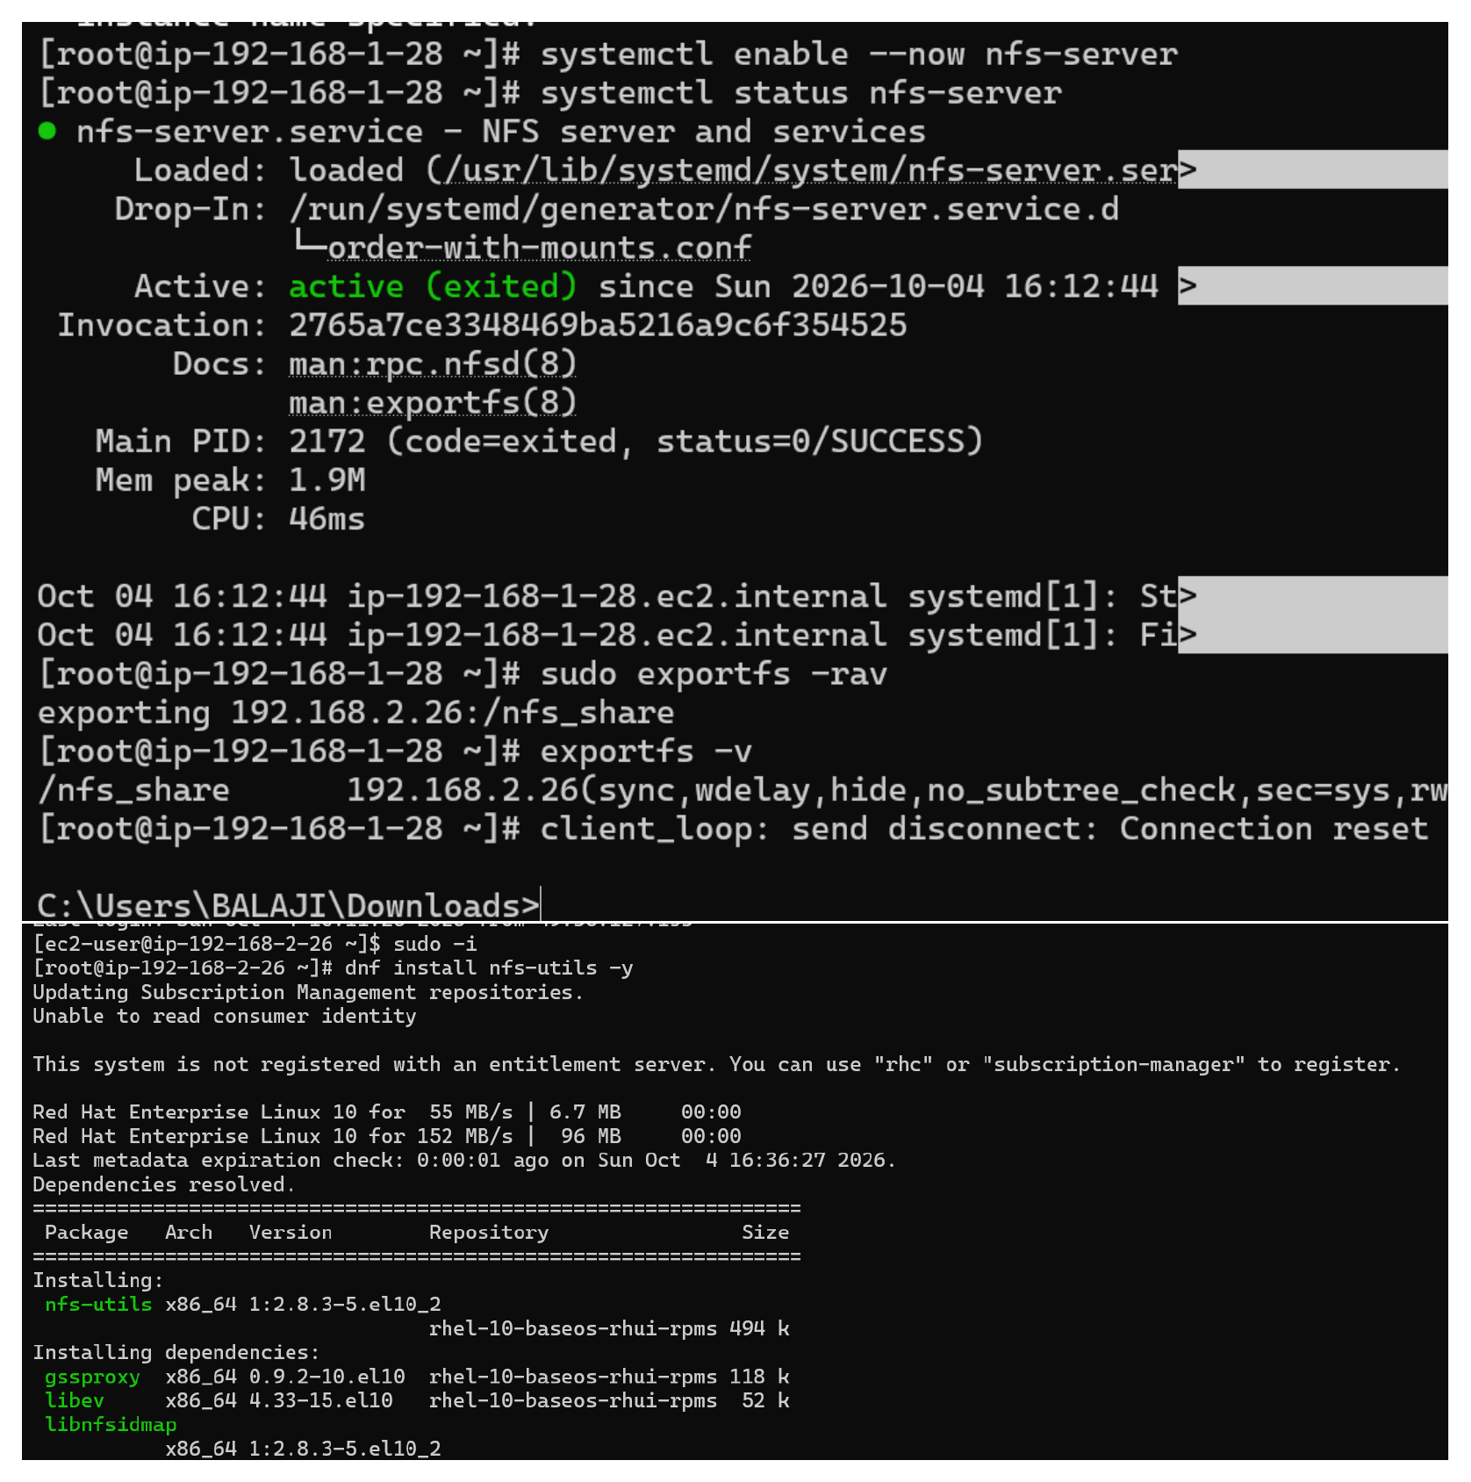
Action: nfs-utils is installed on client-ec2 with dnf. The nfs-client.target is enabled, the client IP 192.168.2.26 is checked, and an initial ping to 192.168.1.28 fails with 100% packet loss.

Allow ICMP and Recheck Client Connectivity
Topic: Permit ping traffic between the two VPCs
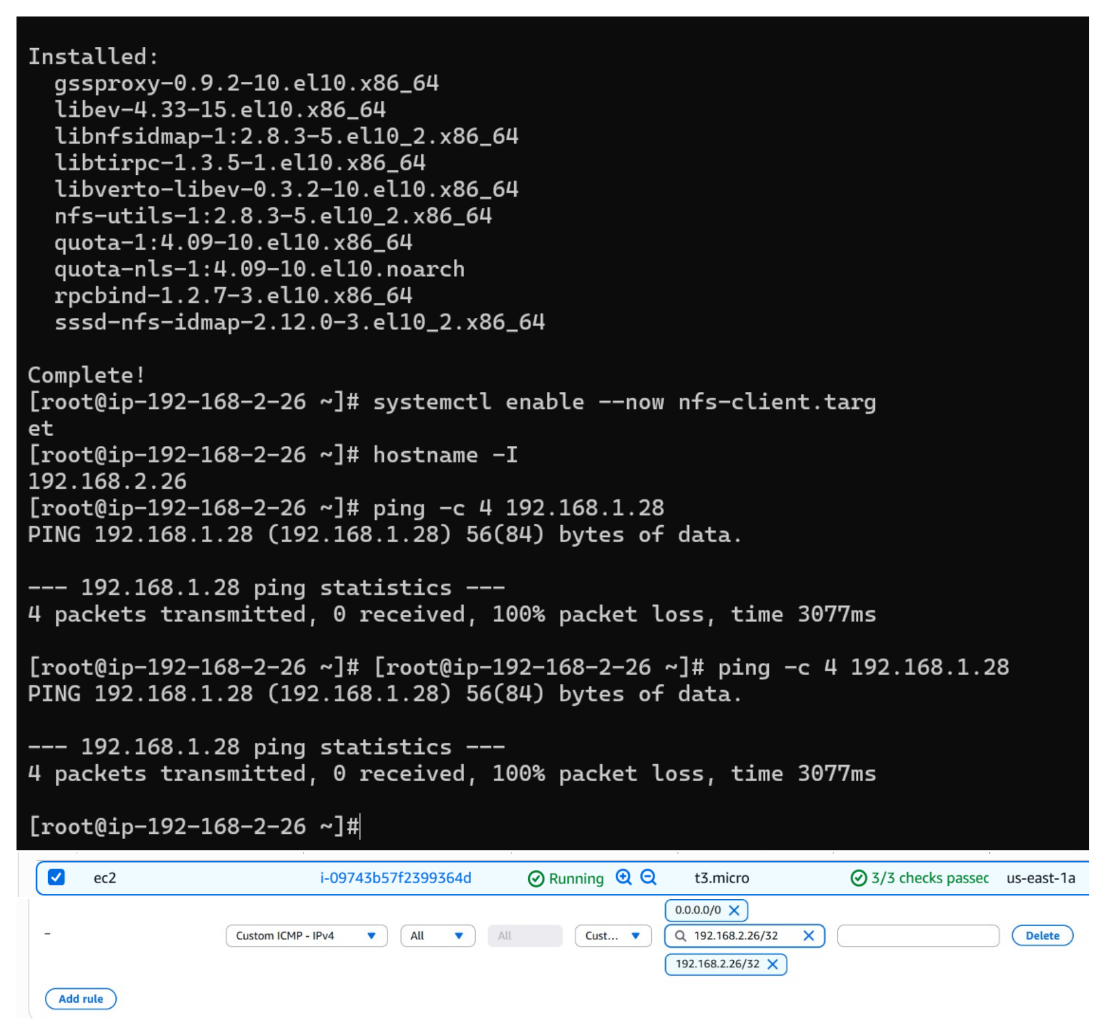
Action: A Custom ICMP-IPv4 inbound rule is added for the shown client source. The client still shows the earlier failed ping in this screenshot, documenting the connectivity issue before peering/routing is completed.

Create the VPC Peering Connection
Topic: Peer the 192.168.1.0/24 VPC with the 192.168.2.0/24 VPC
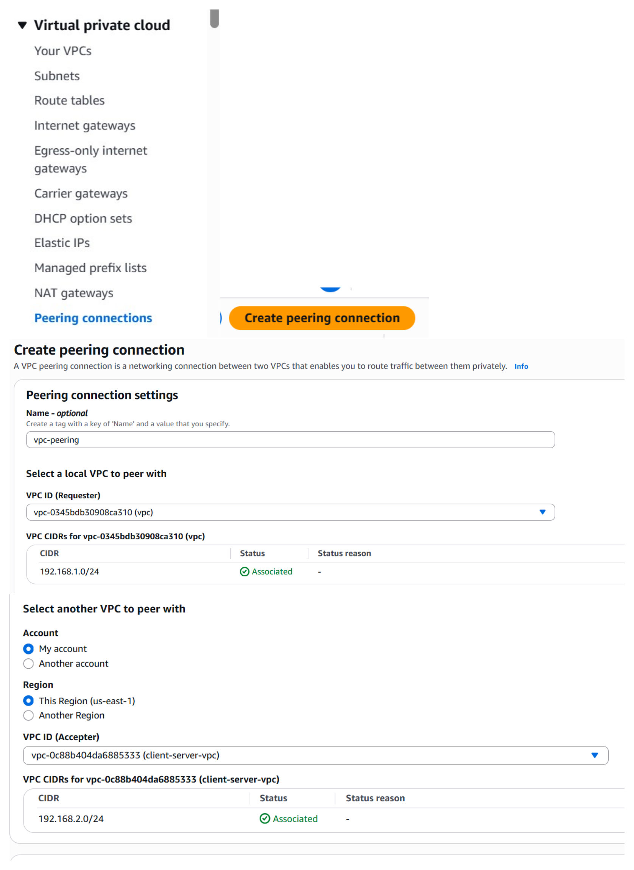
Action: A VPC peering connection named vpc-peering is created between the requester VPC 192.168.1.0/24 and the client-server-vpc 192.168.2.0/24 in us-east-1.

Accept Peering Request and Add Route
Topic: Accept VPC peering and route 192.168.2.0/24 through the peering connection
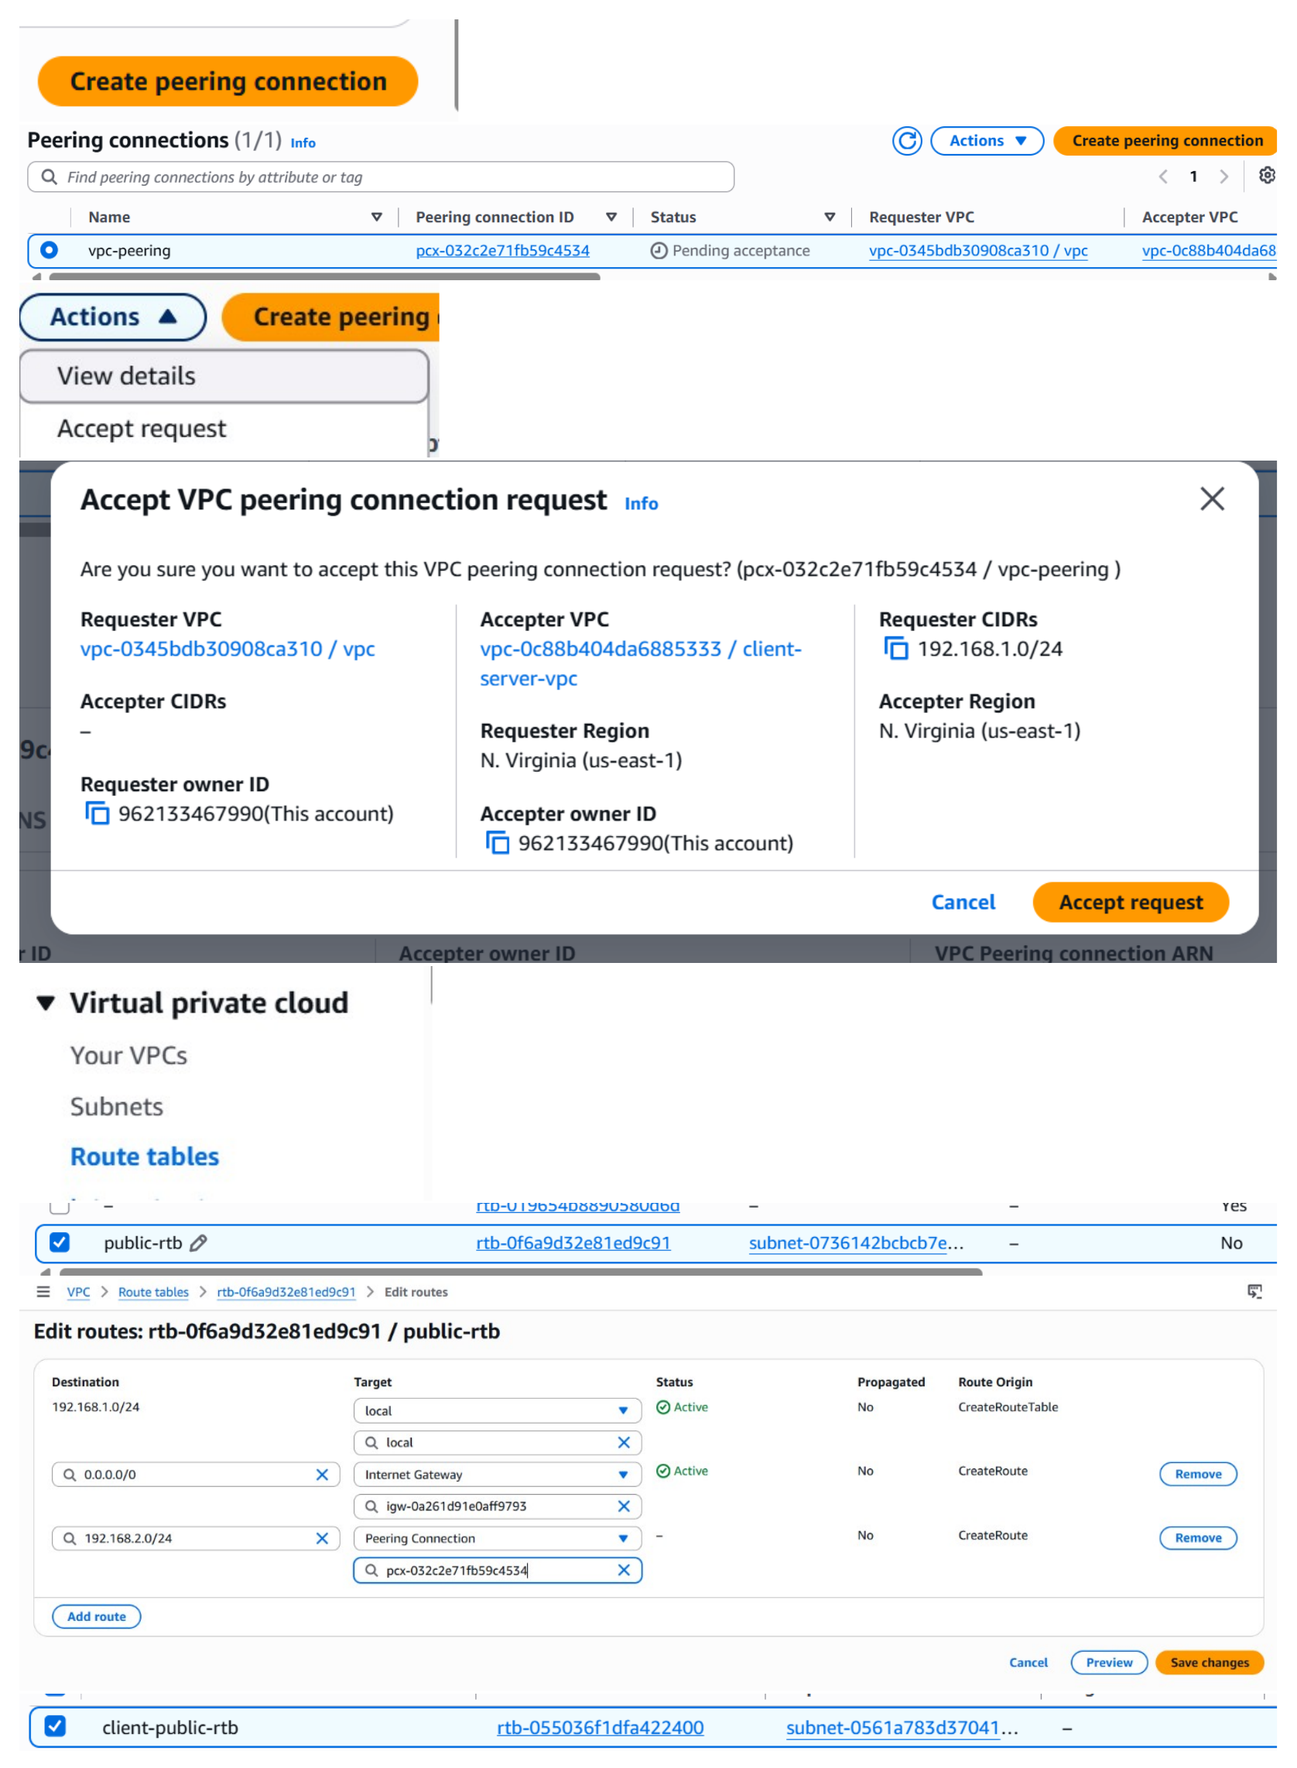
Action: The pending vpc-peering request is accepted. The public-rtb route table is then edited to add destination 192.168.2.0/24 with target Peering Connection pcx-032c2e71fb59c4534.

Complete Return Route and Verify Connectivity
Topic: Add the reverse route and confirm successful network communication
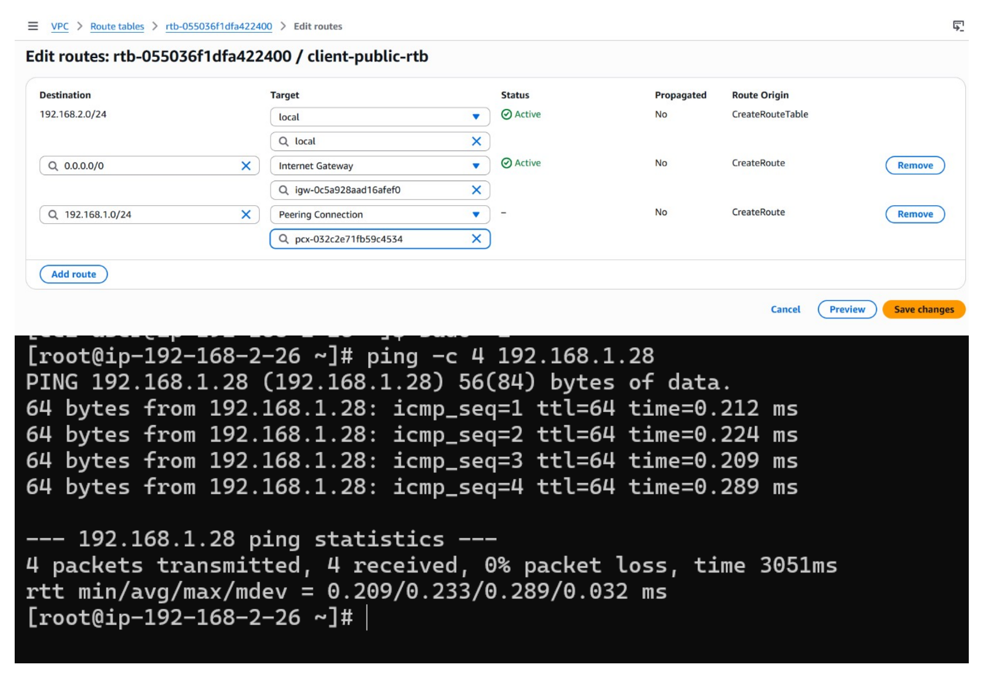
Action: client-public-rtb is configured with a route to 192.168.1.0/24 through the peering connection. The client then pings 192.168.1.28 successfully: 4 packets received and 0% packet loss.

Mount the NFS Share and Verify File Sharing
Topic: Mount /nfs_share on the client and confirm two-way file visibility
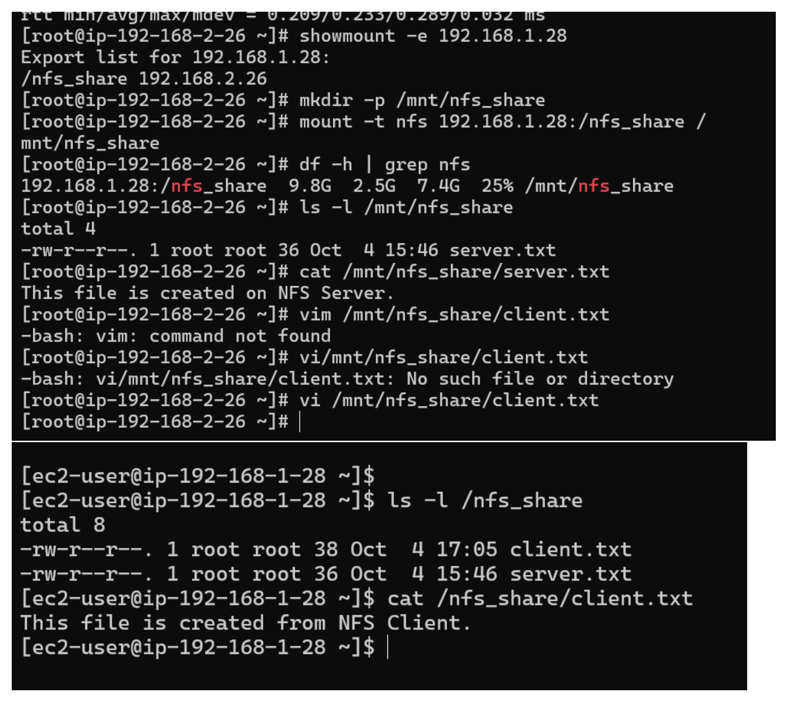
Action: showmount -e lists /nfs_share from 192.168.1.28. The client mounts it at /mnt/nfs_share, reads server.txt, creates client.txt, and the NFS server later lists and reads client.txt with the message “This file is created from NFS Client.”.

